Cultural and Literary Tour to Ireland

Belfast / Dublin 2-6th March 2023
Approximate costs
Flights - www.ryanair.com from 80 euros return
Bratislava - Dublin - Bratislava
Vienna - Dublin - Vienna
Airport Bus - Dublin Airport - Belfast - Dublin Airport from 20 euros
Accomodation
https://www.hini.org.uk/hostels/belfast-international-youth-hostel/ 25 euros per night
http://www.vagabondsbelfast.com/rates/ from 30 euros per person per night with breakfast
Belfast is a student city so prices are cheaper than Dublin. There are numerous eateries, coffee houses and supermarkets.

Take a bookish tour of Belfast
Jessica Prupas
Belfast city rose to prominence during the Industrial Revolution, and its reputation as a global leader in shipbuilding, manufacture and trade is reflected in its sprawling docks and stately Victorian architecture. Today, these refined thoroughfares, including around the buzzy Cathedral Quarter, welcome folk of a literary and musical bent – especially those who like their verse set to a lilting melody and pounding bodhran (and vice versa). For something to really write home about, take a browse around these bookish boltholes. From the rustic ruminations of noted poet Seamus Heaney to Narnia author CS Lewis, Belfast has always offered a fertile wellspring of imagination for writers – and who knows who the city might inspire next?
LINEN HALL LIBRARY
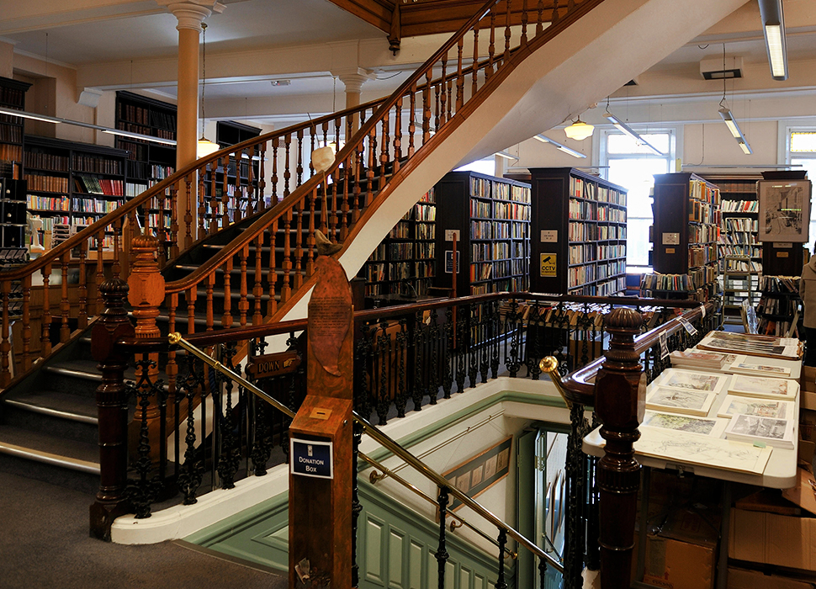
The age-old Linen Hall Library is a bookworm no-brainer. No bookworm mini-break to Belfast would be complete without a pilgrimage to the city’s oldest library, Linen Hall – founded in 1788 on a mission to inspire curious local minds and ‘excite a spirit of general enquiry’. Come for the CS Lewis first editions and eye-opening political paraphernalia, stay for a note-perfect flat white overlooking Donegall Square.
NO ALIBIS
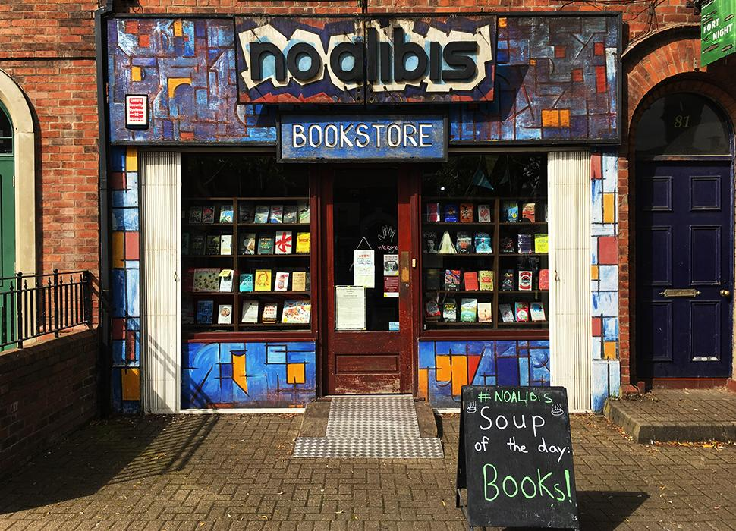
Get lost in a novel at No Alibis. A groovy Belfast bookstore that does stacks more, not least running its own indie publishing business and hosting signings from the likes of local writer Glenn Patterson all the way up to Scandi noir big-hitters such as Jo Nesbø. No Alibis also loves a bit of live music, putting on intimate gigs occasionally attended by high-calibre rock legends including Van Morrison and (who else) Jimmy Page.

CS LEWIS SQUARE
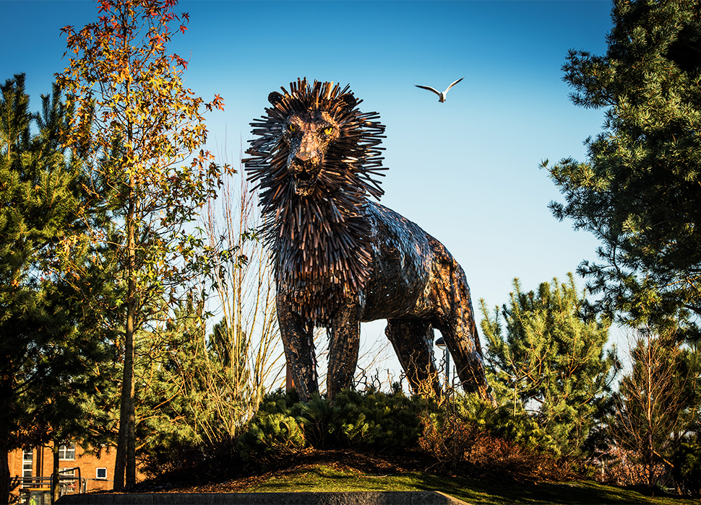 Aslan keeping watch over CS Lewis Square in Belfast / Image: Tourism Northern Ireland
The city’s most famous literary son – Chronicles of Narnia author CS Lewis – is said to have modelled parts of his fantasy world on Belfast’s neighbouring mountains of Mourne. Today his eponymous city centre square features seven bronze sculptures depicting characters from The Lion, The Witch and The Wardrobe. Snarling, spike-haired Aslan is clearly the mane attraction. Other places of interest include.
- 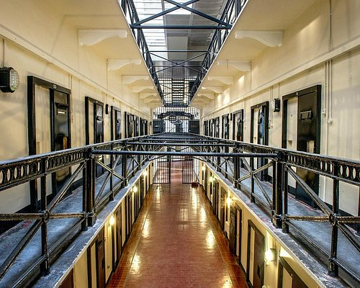

Crumlin Road Gaol

- 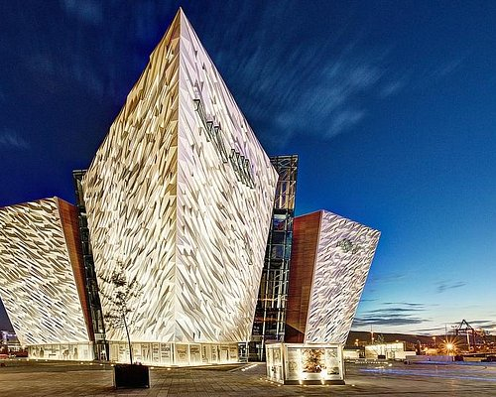

- Titanic Belfast Museum

- 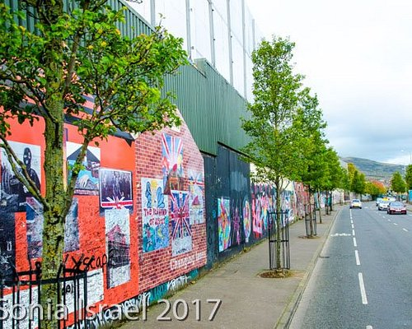

Peace Wall Murals

- 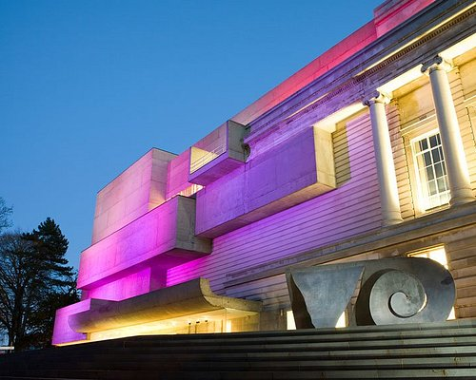
- Ulster Museum - Set in the Botanic Gardens beside Queens University , this is a wonderful museum with amazing exhibits .
- 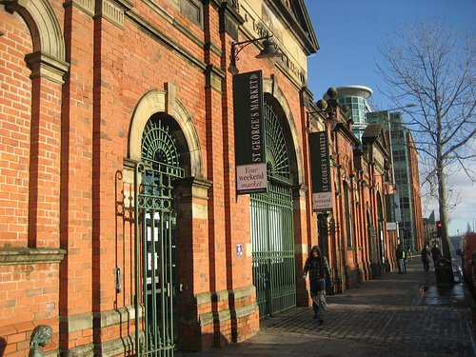

St George's Market is well worth a visit especially on a Saturday where they have a large range of Food stalls and local produce and crafts
- 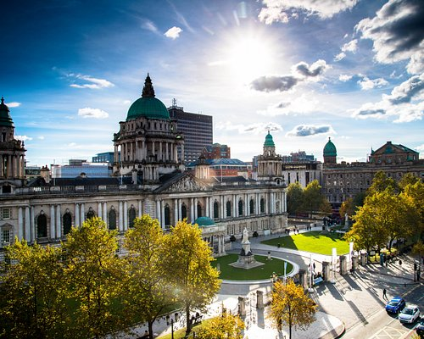

Belfast City Hall - Great free tour and during Christmas the atmosphere and Christmas decoration really make the place magical
- 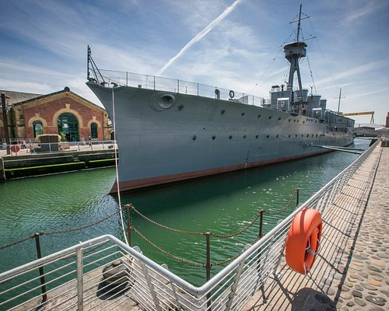
- HMS Caroline

- 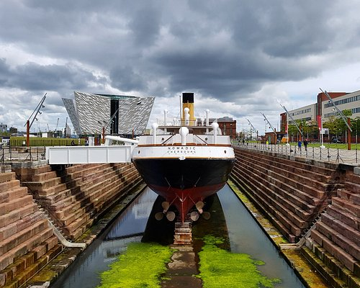
- SS Nomadic Belfast

- 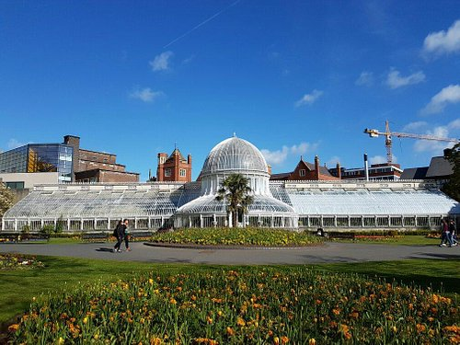

The botanical gardens include a really gorgeous rose garden containing a lot of different varieties arranged in conce...
- 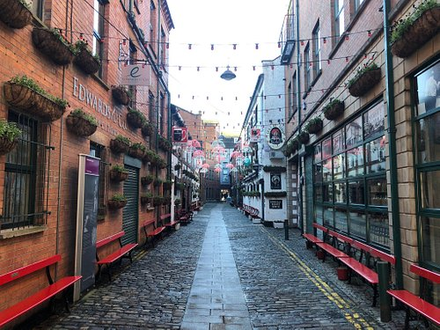
- The Cathedral Quarter

- 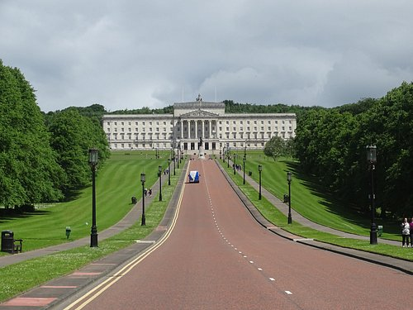
- Parliament Buildings - Stormont Estate Belfast.

- 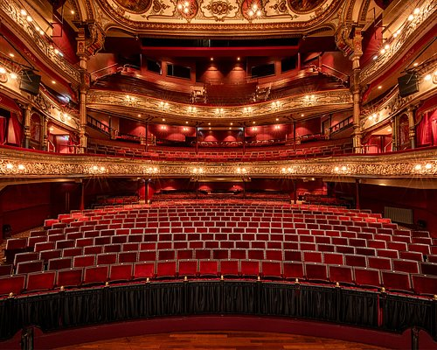
- The Grand Opera House

- 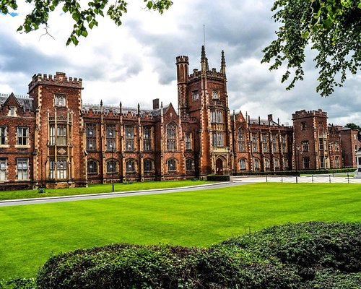

Queens University Belfast

- 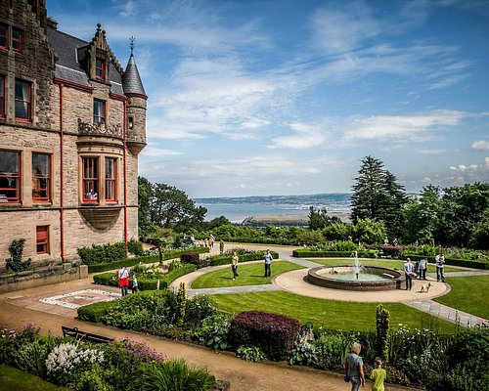
Afternoon Tea at Belfast Castle

- 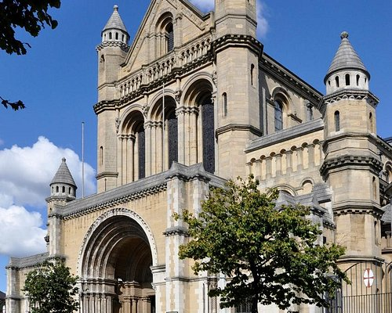
St Anne's which has so much history and interesting stories related to the stained glass windows, plaques etc.

- 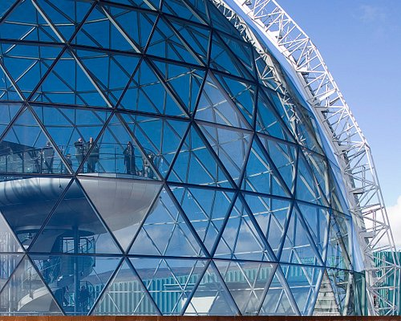
Victoria Square Shopping Centre

Optional Tours

-Black Taxi tour which is very informative about the troubles in Northern Ireland, guided through the key areas by local Irishmen who have experienced the conflict first hand.
The taxi can pick you up at the hostel all day from 9:30 am to 4:40 pm. It costs 20 pounds per person (50 minimum). You can also request the taxi driver to drop you off at a different spot in town.

-Giants’ Causeway/ Game of Thrones tour will take you through the nicer side of the province:
A guided tour which takes you up the Antrim coast stopping along the way at some interesting key points: Carrickfergus Castle, Ballintoy Harbour (Pike), the Dark Hedges (King’s Road) ,and a few more locations before leaving you for 2 hours hike down the Giant's Causeway coast shore.
Tickets cost 25 pounds per person, and the bus departs every morning at 8:00 am and returns around 6:30 pm (timetable may slightly change according to the season)

Dublin Day tour - Return Bus Tickets from 20 euros

1. The Trinity College – closed to the public 2. The Dublin Writers Museum – Call to confirm it is still open 3. The Dublin Castle 4. St Patrick´s Cathedral 5. Three Great Famine memorabilia (e.g. EPIC Emmigration Museum + Famine Memorial + The Jeanie Johnston Ship) 6. Oscar Wilde´s House and statue 7. Any Jonathan Swift´s memorabilia 8. G. B. Shaw´s statue 9. James Joyce´s statue and any other Joycean memorabilia 10. Samuel Becket´s Bridge 11. Eating any typical Irish meal 12. Something only the Irish could do 13. Something only the Irish could wear 14. Something Vikings-related 15. Extra – Kilmainham Gaol, Christchurch Cathedral, www.dublinia.com. https://www.museum.ie/en-ie/home. Send a postcard from the Iconic GPO building.

